DataFusion Platform
Installation & User Guide
A complete, step-by-step walkthrough — with real screenshots for every step
🔒 This app runs 100% offline on your computer. No file, row, or number you import ever leaves your machine or gets uploaded anywhere — that is by design, to protect confidential client data.

1. What is DataFusion Platform?
DataFusion Platform is a desktop tool that takes several messy Excel export files — from different companies, formats, or reports — and turns them into one clean, consolidated Excel workbook. It checks the data for problems (missing values, duplicate rows, duplicate/missing invoice numbers), and produces a single formatted report you can hand to a client or reviewer.
It is an offline desktop application (an .exe program installed on Windows), not a website or a cloud tool. Nothing needs an internet connection to work.

2. Installing the App
You will receive one file: DataFusionPlatform_Setup.exe. This single file installs the whole app — no other downloads are needed.
- Double-click DataFusionPlatform_Setup.exe.
- If Windows shows a security prompt (“Windows protected your PC”), click “More info” then “Run anyway.” This is expected for a new, unpublished app and is safe.
- Click Next on the welcome screen.
- Choose where to install it (the default location is fine for almost everyone) and click Next.
- Click Install, then wait a few seconds for it to finish.
- Click Finish. The app is now installed, and a shortcut is added to your Desktop and Start Menu.
If you are installing an update over an older version, Setup will offer to close the old app for you automatically — just click “Next” and let it.

3. Step 1 — Import Your Files
Open the app from your Desktop shortcut. On the Dashboard, click “Import Files” to pick one or more Excel files, or “Import Folder” to bring in every Excel file inside a folder at once.
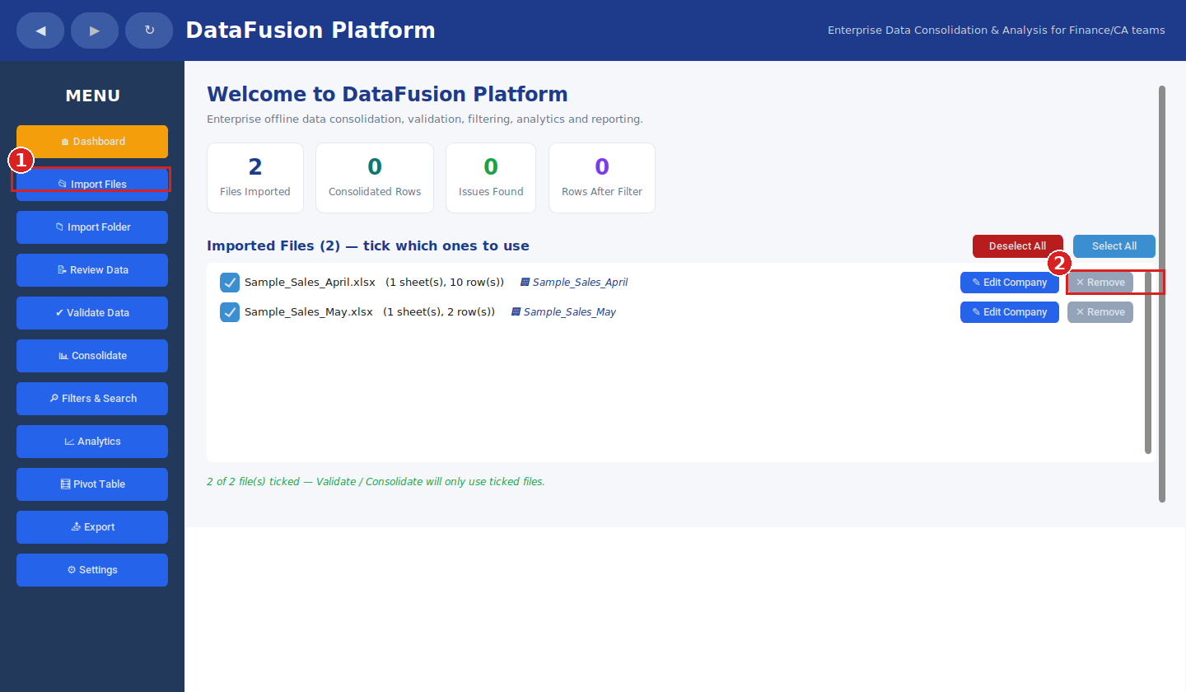
① Import Files — bring your Excel files in. ② Remove — take a file back out of the list.
- ① Import Files — click this in the menu to bring in your Excel files.
- ② ✕ Remove — click this next to any file to take it back out of the list.
- Tick / untick a file's checkbox to include or exclude it from Validate and Consolidate, without deleting it.
- Click “✕ Remove” to take a file out of the list completely, if you imported the wrong one.
- Only .xlsx files are supported. The app reads them but never modifies your original files — it only creates a new, separate export file.
Example — your Excel file, before and after upload
Here is a real sample file next to the app right after clicking “Import Files” — so you can see exactly what to expect the first time you use it.
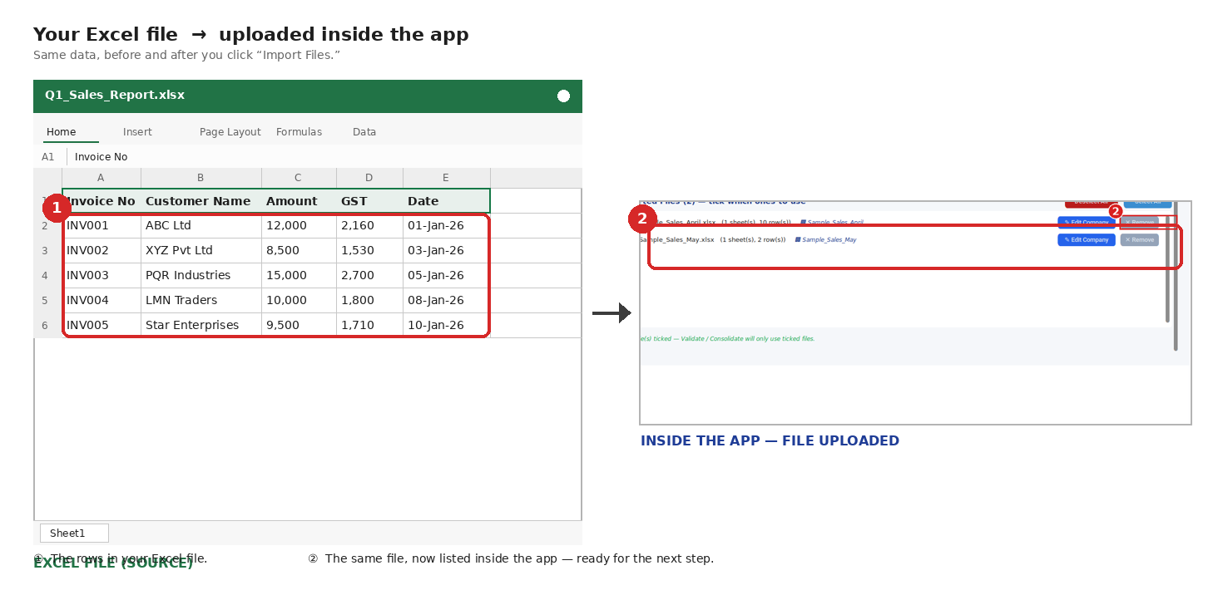
① The rows in your Excel file. ② The same file, now listed inside the app after upload — ready for the next step.

4. Step 2 — Keep As-Is or Auto-Organize?
Some exported reports have extra rows above the real data — a company name, a report title, a “generated on” date — before the actual column headers begin. When the app notices this, it stops and asks you to choose how to handle it:
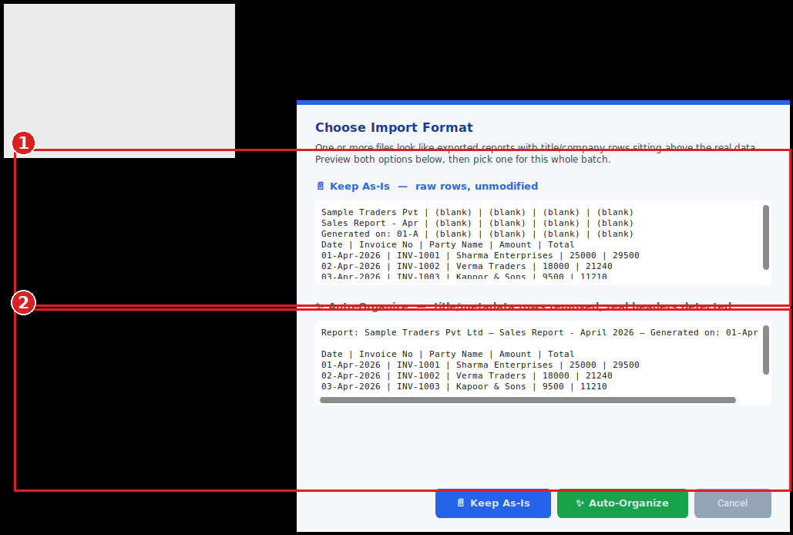
① Keep As-Is — raw rows exactly as found, blank cells included. ② Auto-Organize — title rows removed, real data kept.
- ① Keep As-Is preview — shows the raw rows exactly as they are in the file.
- ② Auto-Organize preview — shows the same data with the title rows removed.

Keep As-Is
Choose this if you want every row imported exactly as it appears in the file — including the title/company-name rows at the top, and any blank cells exactly where they are. Use this when you're not sure, or when those extra rows contain information you want to keep.

Auto-Organize
Choose this if you want the app to automatically detect and remove the title/company rows, so only the real data table (starting from the actual column headers) is imported. Blank cells inside the real data are still kept as-is — only the rows above the real header are removed. This is the better choice when you just want clean, ready-to-use data.
Whichever you pick applies to every file in that import batch. If unsure, Auto-Organize is the safer default for most reports.

5. Step 3 — Validate Data
Click “Validate Data” to have the app check your imported files for common problems: missing required fields, duplicate rows, and duplicate or missing invoice numbers. This step does not change your data — it only reports what it finds, right inside the app.
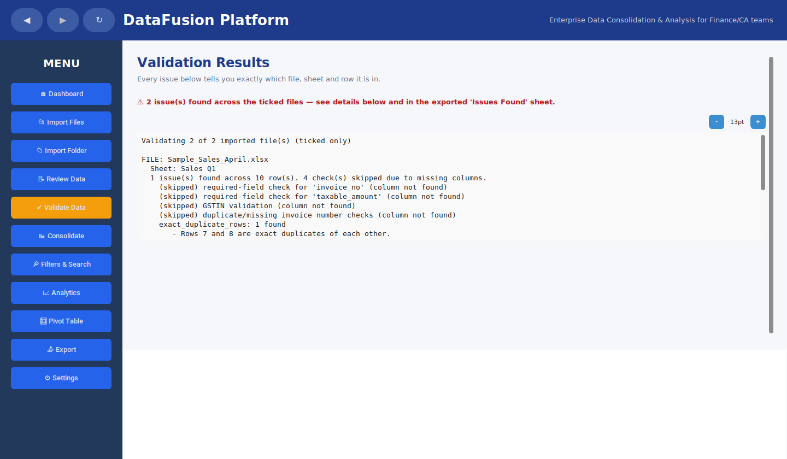
The Validate Data screen — a plain-English list of every problem found, file by file.

6. Step 4 — Consolidate, then Step 5 — Export
Click “Consolidate” to merge all your ticked files (and, if a file has multiple sheets, the specific sheets you choose) into one combined dataset. Once consolidated, click “Export” and choose where to save the final report.
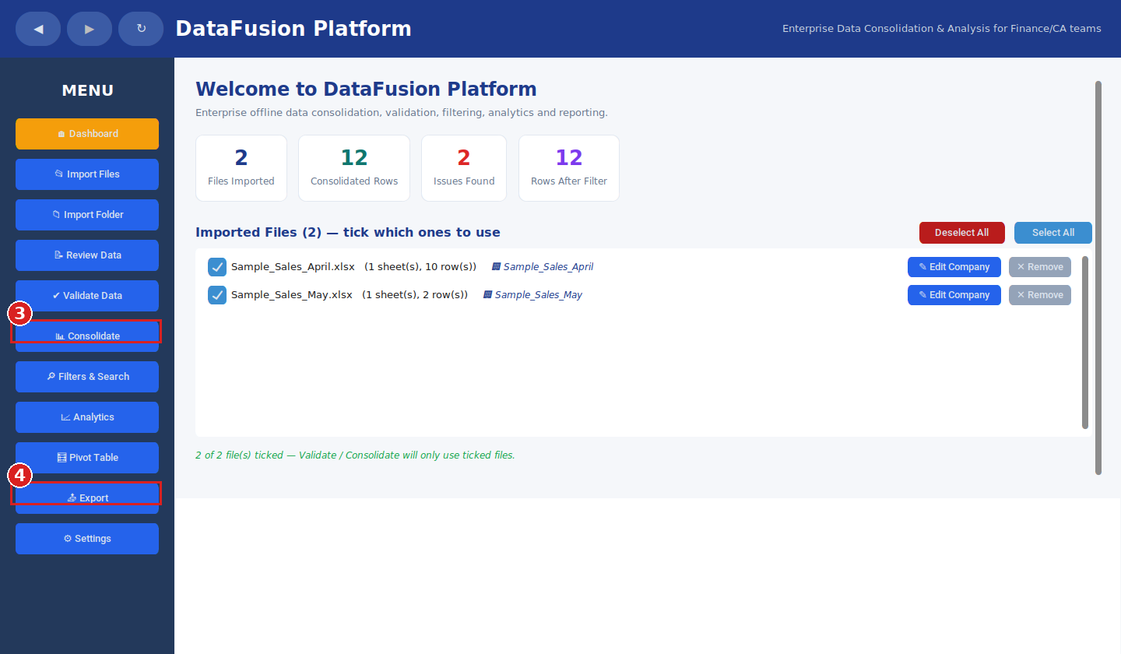
③ Consolidate — merges your ticked files. ④ Export — saves the final report.
- ③ Consolidate — click this to merge your ticked files into one dataset.
- ④ Export — click this to save the final report to your computer.
The exported workbook has several tabs:
- Summary — totals, file list, and a Debit/Credit checkpoint
- Source Files — every file that went into this report, with a link to open it
- Consolidated Data — all your merged rows in one table
- Company Summary — totals grouped by company
- Issues Found — every problem detected during validation, color-coded by type

The Consolidated Data tab
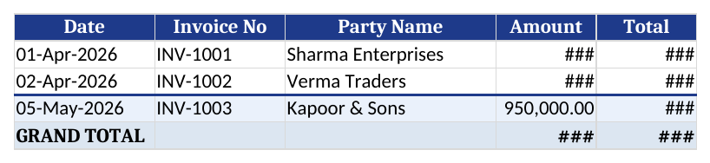
Every row from every file you selected, merged into one table. Numbers are shown in Indian format (e.g. 25,00,000.00).

7. The Debit = Credit Checkpoint — and How to Solve It
If your data has Debit and Credit columns, the app automatically adds up every Debit value and every Credit value the moment you click Consolidate, and compares the two totals. In a correctly maintained set of books, total Debit should always equal total Credit.

✔ If the totals match
Consolidation finishes immediately and takes you straight to your results. No action needed.

⚠ If the totals don't match
The app stops right there and shows this popup — it will not let a mismatched consolidation go through silently:
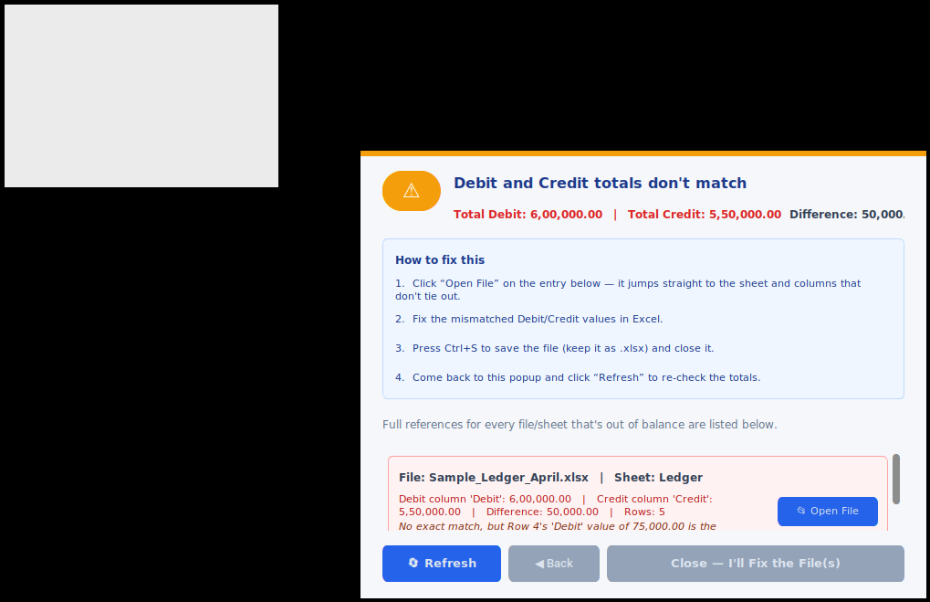
The real Debit/Credit Checkpoint popup. It lists exactly which file and sheet is out of balance, and often points at the single most likely row to check first.
This popup is entirely self-explanatory, with its own “How to fix this” steps built right in:
- Click “📂 Open File” on the entry listed — it jumps straight to the sheet and columns that don't tie out (and, when possible, highlights the single row most likely to be the cause).
- Fix the mismatched Debit/Credit values directly in Excel.
- Press Ctrl+S to save the file (keep it as .xlsx) and close it.
- Come back to this popup and click “🔄 Refresh” — it re-checks the totals immediately, without restarting the whole import/consolidate process from scratch.
If “Refresh” still shows a mismatch and no single row is pointed at, the guidance text in the popup will say so directly — that usually means a transaction is missing entirely, rather than one existing entry being wrong.
Once everything ties out, the same Debit/Credit totals also appear on the Summary tab of your final exported report, as a permanent record:

The Checkpoint block as it appears in the exported Excel report's Summary tab.

8. The Issues Found Tab — What Each Colour Means and How to Fix It
Each type of issue has its own colour, with a legend at the top of the sheet so nothing needs to be explained out loud. Every row tells you the file, the sheet, and a plain-English sentence describing the exact problem.
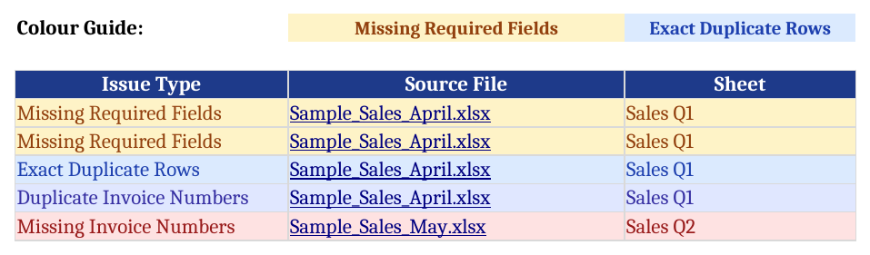
Color-coded by issue type. The Source File column is a clickable link back to where the problem came from.
Amber — Missing Required Fields
What it means: a cell that the app expects to always have a value (like Amount or Invoice No) is empty in that row.
How to fix it: open the source file named in that row, go to the exact row mentioned, and fill in the missing value. Save the file, then re-import and re-export.
Blue — Exact Duplicate Rows
What it means: two rows in the same sheet are 100% identical in every column — almost always caused by copy-pasting or exporting the same data twice.
How to fix it: open the source file, go to the two row numbers mentioned, confirm they really are duplicates, and delete one of them. Save, then re-import and re-export.
Indigo — Duplicate Invoice Numbers
What it means: the same invoice number appears on more than one row, but the rows are not identical — either a genuine duplicate entry, or two different transactions accidentally given the same invoice number.
How to fix it: open the rows listed and check which case it is. If it's a real duplicate, delete the extra row. If they are two different valid transactions, give one of them the correct/next invoice number. Save, then re-import and re-export.
Red — Missing Invoice Numbers
What it means: the app noticed your invoice numbers follow a sequence (e.g. INV-1001, INV-1002, INV-1003…) and one number in that sequence never appears.
How to fix it: first check if that invoice was legitimately cancelled or voided — if so, no action is needed. If it was never meant to be missing, locate the invoice and add it to the source file. Save, then re-import and re-export.
General rule: after fixing anything in a source file, always re-import that file and export again — the app never edits your original files automatically, so a fix only takes effect once you bring the corrected file back in.

9. Data Privacy
DataFusion Platform is fully offline. It does not connect to the internet, does not upload files anywhere, and does not send any data outside your computer. All processing happens locally, and only you decide where the exported report is saved. This is by design, to protect confidential client and company data.

10. Quick Troubleshooting
- The app won't open — make sure you installed it via the Setup.exe (don't run files from inside a zip folder).
- A file won't import — confirm it is a real .xlsx file, not .xls or a password-protected file.
- An old version's behavior seems to still be showing — close the app fully via Task Manager, then reopen it and try again.

